- Brake Fluid Life Minder - Time (Days) to Reset, Reset Function, and Warnings 2019.5 V36x MCA Vehicle Maintenance Monitor – CGEA1.3

Functional Description

This STSS supports the new Brake Life Minder feature. The first application is 2019.5 V36x MCA Diesel applications, however, the applications engineer must verify the actual use of this STSS as per the PDL and powertrain.

This is a new feature which reminds the driver to change the brake fluid on a fixed interval basis.

All values relative to Brake Fluid Life (Months to service) are calculated in ABS Module and sent to IPC via
CAN signal. All warnings relative to Brake Fluid Life are commanded via CAN signal from the Brake Module.

Interfaces

Interface Context Diagram (I/O Block Diagram)

Figure 1: Brake Fluid Life Minder Months to Service and Warning Function
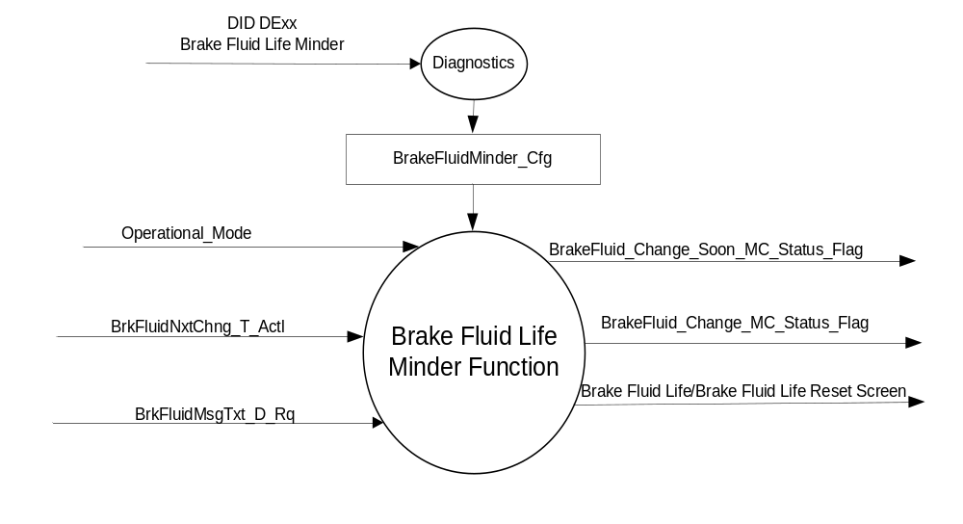

Inputs
      - INTERNAL:
          - Operational_Mode
          - Brake_Fluid_Minder_Cfg

      - MUX messages on the CAN bus from ABS

- BrkFluidNxtChng_T_Actl Signal
Signal Name | Size  (bits) | Detail | Units | Res. | Offset | State Encoded | Min. | Max.
BrkFluidNxtChng_T_Actl | 7 |  | months | 1 | 1 |  | 0 (0x0) | 127 (0x7F)

- BrkFluidMsgTxt_D_Rq Signal
Signal Name | Size  (bits) | Detail | Units | Res. | Offset | State Encoded | Min. | Max.
BrkFluidMsgTxt_D_Rq | 2 |  | SED | 1 | 0 |  | 0 (0x0) | 3 (0x3)
 |  | NoMessage |  |  |  |  | 0x0
 |  | ChangeBrkFluidSoon |  |  |  |  | 0x1
 |  | ChangeBrkFluidNow |  |  |  |  | 0x2
 |  | ResetComplete |  |  |  |  | 0x3

Outputs
- BrakeFluid_Change_Soon_MC_Status_Flag that is used to control the Warning displayed in the message center.
- BrakeFluid_Change_ MC_Status_Flag that is used to control the Warning displayed in the message center.
- MUX message on the CAN bus to the ECM/PCM:

- BrkFluidLife _B_RqReset Signal
Signal Name | Size  (bits) | Detail | Units | Res. | Offset | State Encoded | Min | Max
BrkFluidLife _B_RqReset | 1 |  | SED | 1 | 0 |  | 0 (0x0) | 1 (0x1)
 |  | No |  |  |  | 0x0
 |  | Yes |  |  |  | 0x1

Function/Performance

Operational Modes

Mode | Differentiating Vehicle Conditions
Sleep Mode | Brake Fluid Life Minder Inactive
Limited Mode | Brake Fluid Life Minder Inactive
Normal Mode | Brake Fluid Life Minder Active
Crank Mode | Brake Fluid Life Minder Active

Voltage Levels

Refer to the Cluster Features Table located in the Operational Modes and Voltage Range Strategies
Section of this SPSS

Human-Machine Interface

Visual

Indicator Graphics / Display Format
Warning and Settings

Indicator Color Coordinates
Reference section COLOR & ILLUMINATION REQUIREMENTS (GRAPHICS)

Indicator Characteristics

Refer to Message Center X Display_Y Button Interface Section, where X and Y are appropriate values in this document.

Audio

No Message Center Warning Chime is associated with this Warning.

Switch Control Logic

Refer to Message Center X Display_Y Button Interface Section, where X and Y are appropriate values in this document, for System Check and Warning behavior.

System Accuracy

Brake Fluid Life Minder Function shall be processed by the Message Center so that any human requests are processed within 100 ms of receipt of request.

Operation: Performance and Functional

Subsystem Algorithm Flowchart / State Diagrams

Figure 2: Brake Fluid Minder Configuration

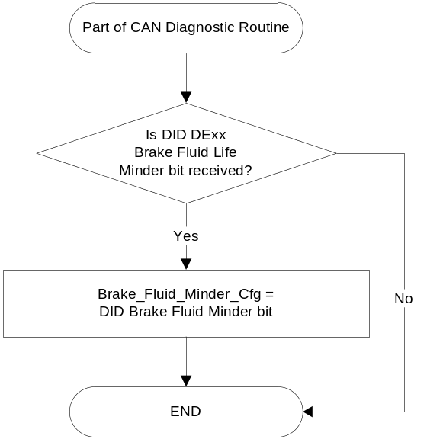

Figure 3: Brake Fluid Life Reset Function

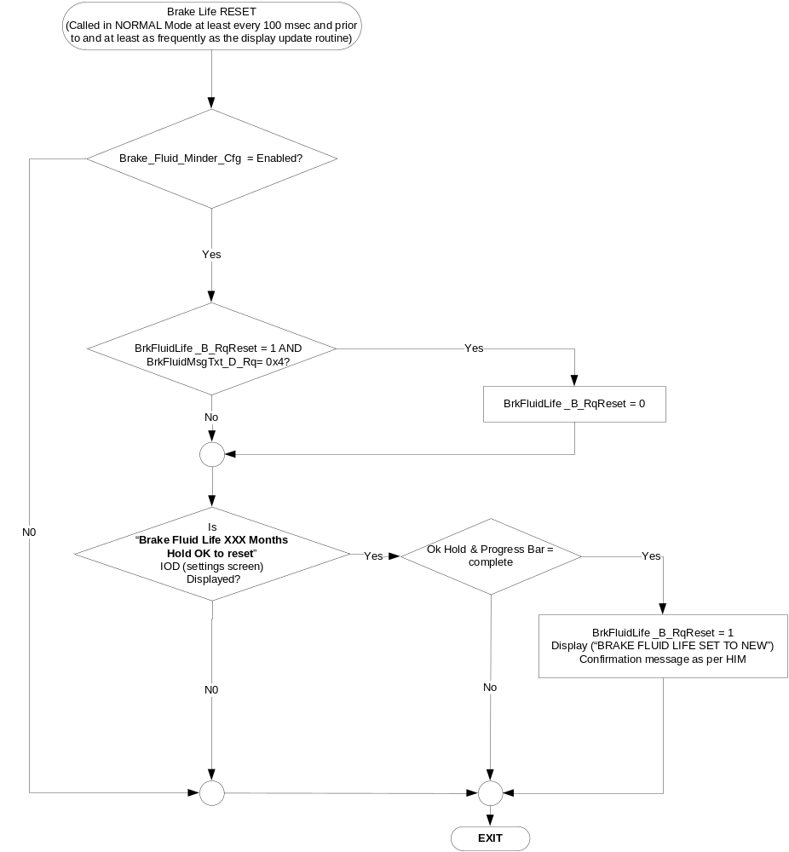

Figure 3: Brake Fluid Life/Brake Fluid Life Reset Screen
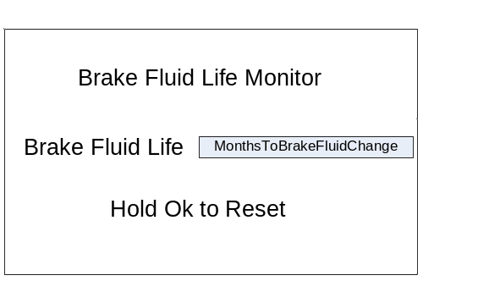
Notes:
- MonthsToBrakeFluidChange Variable values are as per Table 1.4. Text and text style will vary as per HMI.
- If VMM_Cfg = Enabled then the screen shown in Figure 3 is drilled down to from the High Level Vehicle Maintenance screen. If VMM_Cfg = Disabled and the above screen is enabled then the above screen shall be shown will be in a different location as per HMI.

Table 1.4 MonthsToBrakeFluidChange
BrkFluidNxtChng_T_Actl Signal | MonthsToBrakeFluidChange  (must support 3 digits)
127 (0x7F) | Value (BrkFluidNxtChng_T_Actl Signal)
Not Received l Declared Missing as per 1.4.1 | Dashes (---)

Table 1.5 Oil Change Warning Function
Operational  _Mode | Brake_Fluid  _Minder_Cfg | BrkFluidMsgTxt  _D_Rq Signal | BrakeFluid_Change  _Soon_MC_Status_Flag | BrakeFluid_Change  _MC_Status_Flag
Normal or Crank | Enabled | ChangeOilSoon (0x1) | Active | Inactive
Normal or Crank | Enabled | ChangeBrkFluidNow (0x2) | Inactive | Active
All Other Cases |  |  | Inactive | Inactive

Table 1.6 MC_Status_Flag to Message ID (W#)
BrakeFluid_Change  _Soon_MC_Status_Flag | BrakeFluid_Change_ MC_Status_Flag | MC Message ID
Active | Inactive | W206
Inactive | Active | W207

Operation Description (supports algorithm flowchart /state diagram)
- This feature is enabled and the associated IOD (settings screen) is shown only if
Brake_Fluid_Minder_Cfg = Enabled

Function Safety Classification (EMC)

Class A

Memory Storage

Parameter Name | Description | Value at  Battery Connect | Value at  Module Wake-up
BrkFluidNxtChng_T_Actl Signal | Can Signal Sent from ABS | 0 (0x0) | 0 (0x0)
BrkFluidMsgTxt_D_Rq Signal | Can Signal Sent from ECM/PCM | 0 (0x0) | 0 (0x0)
BrkFluidLife_B_RqReset Signal | Can Signal Sent from IPC | 0 (0x0) | 0 (0x0)
BrakeFluid_Change_Soon_MC_Status_Flag | State variable used by M/C Warning Arbitrator | Inactive | Inactive
BrakeFluid_Change_ MC_Status_Flag | State variable used by M/C Warning Arbitrator | Inactive | Inactive
Brake_Fluid_Minder_Cfg | Used to enable Brake Fluid Minder Feature | Use Stored Value | Use Stored Value
Operational_Mode | 4 state indicator for cluster operational mode | Limited | Limited or Normal or Crank

Prove Out

None.

Reconfigurable Telltale

No

Message Center Msg

As per Table 1.8 and as per below:

MC Warning Message ID
W206
W207

Error Handling

Missing Message Strategy

The signals will be declared missing as per the Diagnostics section of this SPSS.

DTCs states and history will be determined as per the Diagnostics section of this SPSS.

Diagnostics

Self Test

None

Engineering Test Mode

Reference section “Dealer / Engineering Test Mode (ETM)”

Part II Performance

Supported Diagnostic Trouble Codes (DTCs)
DTC | Description
C12100 | Lost communication with Anti-Lock Brake System (ABS) Control Module

DID $DExx
Block  Num | Block Description | Type | Byte(s) | Bits | State: Description | "0" | "1" | Default | Comments/  Information
PACKETED BLOCKS
$xx | Option Content (B&A) | 1 | * | * | Brake Fluid Life Minder | Disabled | Enabled | Disabled

Reference Specification

Revision History

SPSS Module Revision History

Revision Level | Name | Change Description | Date
1.0 | J.Blatchford | Initial Release | 12/20/16
1.1 | J. Blatchford | Added W206/W207 | 5/24/17

